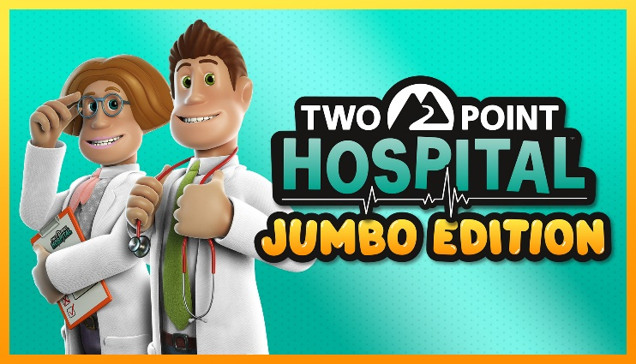

Two Point Hospital: JUMBO Edition Out Now on Consoles!
And it’s absolutely huuuuuge!
What do secret government facilities and giant eco-cities have in common? They are both exciting new places to visit in Two Point Hospital: JUMBO Edition – out now on PlayStation® 4, Microsoft Xbox® One and Nintendo™ Switch! Check out how jumbo JUMBO really is here.
JUMBO Edition brings a jam-packed bundle including the base game, four expansions and two item packs for a total of 27 hospitals, 189 illnesses and lots of items to place in your hospitals! Players can travel to new areas in Two Point County and discover extra-terrestrial species in Close Encounters or join Two Point County’s mayor on her journey to ecological success in Off the Grid.
JUMBO Edition Content:
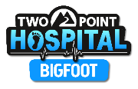
Bigfoot brings you to the wintery region of Pointy Mountains, where local celebri-yeti Bartholomew F. Yeti, has been petitioning for better healthcare. Mr Yeti will need your help, curing new illnesses such as Cold Shoulder, Bard Flu, and Aurora Snorealis!
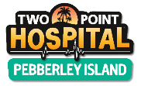
In Pebberley Island you begin your adventures in the gentle climes of Pebberley Reef, before pushing into dense, unexplored country in Overgrowth, to finally conquer the stunning Topless Mountain as you attempt to unlock the lost secret of eternal youth.
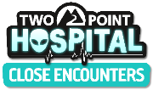
In Close Encounters rumours persist of an out of this world encounter. Deal with conspiracies, secret facilities and more unusual illnesses like Science Friction and Lack of Humanity. Maybe you’ll get to see some aliens…
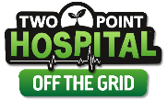
For anyone who’s more into Green Things and Mother Nature… no problem! In Off The Grid you’ll manage new and exciting gameplay mechanics. Visit Two Point County’s first eco-city, get gardening and don’t catch any Root Snoot or Green Fingers!
Turn back the clock with a delightful collection of 26 retro and vintage items to place in your hospitals with the Retro Items Pack or channel your inner artist with the Exhibition Items Pack. More information about the expansions and item packs can be found here.
The physical version of Two Point Hospital: JUMBO Edition can be purchased via www.twopointhospital.com for PlayStation 4 and Nintendo Switch. Players around the world can buy JUMBO Edition digitally on all platforms via the first party store fronts. Fans that already own Two Point Hospital on consoles can purchase the new content separately via the first party store fronts. JUMBO Edition is also playable on the Xbox Series X|S and PlayStation 5 via backwards compatibility.
For more information about JUMBO Edition and all other things Two Point Hospital head to www.twopointhospital.com. You can follow the game on YouTube, Facebook and Twitter. For more information about SEGA Europe, log on to www.sega.co.uk, follow us on Facebook, Instagram, YouTube on Twitter.

